**EXPERIMENT – 6**

**PART - B**

AIM :

Create business report for Health care analysis in power bi desktop by using Health related dataset

1. Import data from various sources.
2. Use Power Query for data cleaning and transformation.
3. Create relationships between tables.(if any)
4. Filter and slice your data and use drill-down capabilities for deeper analysis.
5. Create calculated columns and measures using DAX.
6. Create different types of charts, tables and Use slicers and filters effectively.
7. Design interactive dashboards.
8. Analyze the data to identify meaningful insights and make data driven
9. decisions.

**1. Import Data from Various Sources**

*Objective:* To bring all necessary data into Power BI for analysis.

*Steps:*

* *Open Power BI Desktop:* Launch the Power BI Desktop application.
* *Get Data:* Click on the "Get Data" button located on the Home ribbon.
* *Choose Data Source*: Select the type of data source you want to connect to (e.g., Excel, CSV, SQL Server, SharePoint, etc.). Power BI supports a wide range of data sources including cloud-based services like Azure and web-based data.

* *Connect to Data Source:* Follow the prompts to establish a connection.
* For instance, if you are importing data from an Excel file:
* Click on "Excel".
* Browse and select your Excel file.
* Click "Open".
* Load Data: In the Navigator window, select the tables or sheets you want to import and click "Load" to bring them into Power BI.
* 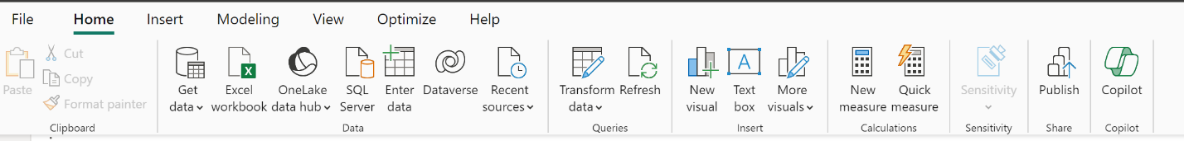 Ensure your data is clean and well-structured in the source files.
* Power BI can handle large datasets efficiently, but consider the size and complexity of the data you're importing.

**2. Use Power Query for Data Cleaning and Transformation**

*Objective:* To prepare and clean the data for analysis.

*Steps*:

* A screenshot of a computer

  Description automatically generatedLaunch Power Query Editor: After importing your data, click on "Transform Data" to open the Power Query Editor.

*Data Cleaning:*

* Filter Rows: Use the filter options on column headers to include or exclude specific rows.
* Handle Missing Values: Replace or remove missing values using the "Replace Values" or "Remove Rows" options.

*Data Transformation:*

* Change Data Types: Ensure columns have the correct data types (e.g., dates, numbers, text). Right-click on the column header and select "Change Type".
* Add Custom Columns: Use the "Add Column" tab to create new columns using custom formulas.

To create custom columns: Add required columns using Custom column of Add column

**3. Build Calculated Columns and Measures Using DAX**

*Objective:* To perform advanced calculations and derive new insights from your data.

* DAX (Data Analysis Expressions) is a powerful language for creating complex calculations and aggregations.

*Steps:*

* *Open Data View*: Click on the "Data" icon on the left sidebar to view your tables.
* *Create Calculated Column:*
* 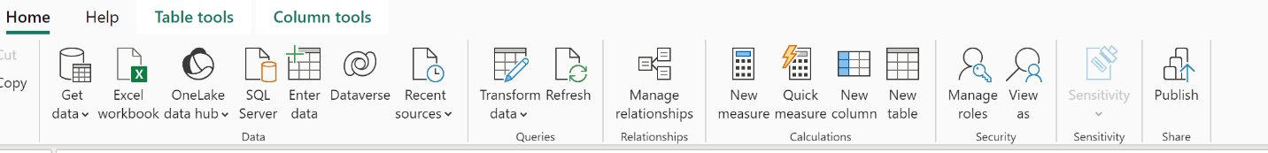*New Column:* Click on "New Column" in the "Home" ribbon of table view.
* *DAX Formula*: Enter a DAX formula to define the new column.

For example, to calculate profit margin: Profit Margin = DIVIDE([Profit], [Sales]).

* *Create Measures:*
* New Measure: Click on "New Measure" in the "Home" ribbon of table view.
* *DAX Formula*: Define a measure using DAX.

For example, to calculate total sales: Total Sales = SUM(Sales[Amount]).

* Calculated columns are evaluated row by row, whereas measures are aggregated calculations.

To achieve given objectives we need to find the following :

**4. Create Different Types of Charts, Tables, and Use Slicers and Filters Effectively**

*Objective:* To visualize data in various forms to communicate insights clearly.

*Steps:*

*Add Visualizations:*

* *Select Visualization Type*: From the "Visualizations" pane, choose a chart type (e.g., bar chart, line chart, pie chart).
* *Drag Fields*: Drag and drop fields onto the visual to populate it with data.

*Customize Visuals:*

* *Format Visual:* Use the "Format" pane to customize the appearance of the visual (e.g., colors, labels, titles).
* *Add Legends and Tooltips:* Enhance visuals by adding legends and tooltips for better clarity.

*Use Slicers and Filters:*

* *Slicers:* Add slicers to allow users to filter data dynamically.
* *Filters:* Apply visual-level, page-level, or report-level filters as needed

**5. Design Interactive Dashboards**

Objective: To create a user-friendly and interactive interface for data exploration.

Ensure the dashboard is intuitive and user-friendly.

Interactive elements should enhance the user experience without overwhelming them.

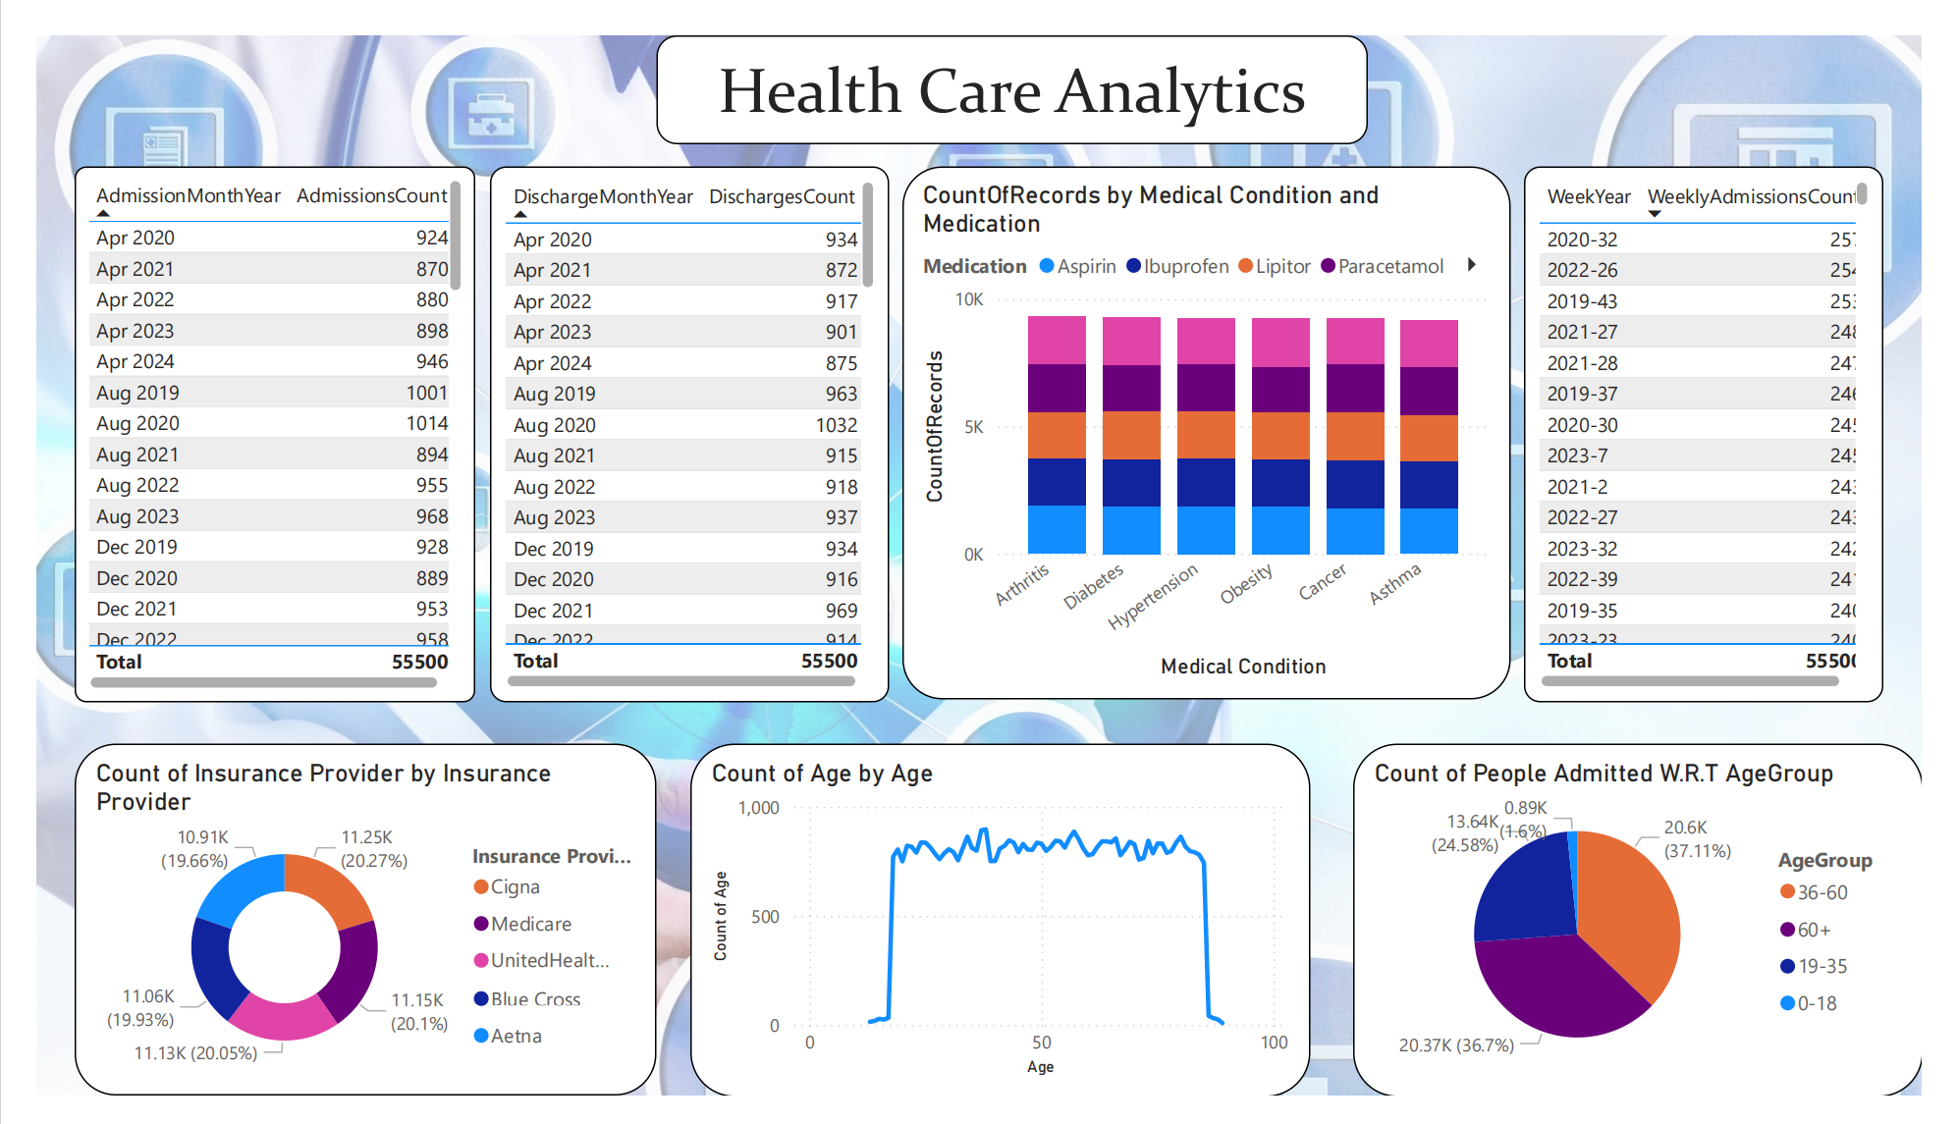

**Result :**

Health Care Analysis dashboard is generated according to the requirements and insights are generated from the dashboard